Biophysical-Semeiotic Preconditioning.

Introduction.

Since the second half of last century, physical semeiotics gradually devoloped in a excellent manner. Based on auscultatory percussion – an old, obsolete method of investigation, i.e. out of the use, nowadays, I brought up-to-date starting from 1955 (although overlooked by almost all Authors) (1) – Reflex-Diagnostic-Auscultatory Percussion, originated in 1970, revealed essential in evaluating microvessels in every biological system, from both structural and functional point of view. In fact, the method allowed me to discover three ureteral reflexes (upper, middle and lower uretral reflex ), necessary to study at the bed-side the microcirculatory bed and the microcirculation (1,2,3) (Fig.1, 2).

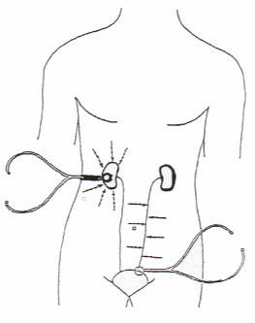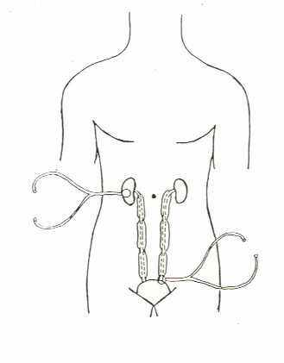

Fig.1 Fig.2

As far as biophysical semeiotic preconditioning is concerned, however, doctor has to know at least the auscultatory percussion of the stomach, described somehow in old academic books and easy to perform at the bed-side (Fig.3).

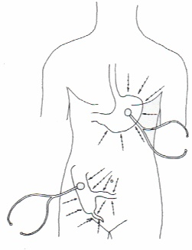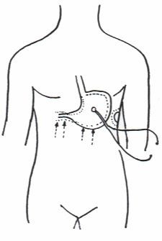

Fig.3 Fig.4

The subject is laying down on supine position and the bell-piece of stethoscope is placed on the right position, i.e. on the skin-projection area of stomach body; doctor performs digital percussion with the pulp of a finger directly and gently on the skin, two times on the same point, starting far away from the bell-piece of stethoscope and moving towards it, along radial lines, as Fig. 2 clearly indicates. When digital percussion is applied directly upon the skin projection area of stomach (great curve), sound is perceived more intense, loud, hyperphonetic as originating near to doctor’s ears.
In practice, outlining a short tract of the great curve is technically proper for achieving the correct biophysical semeiotic preconditioning of all organs, namely the accurate evaluation of present and future situations of wathever biological system.
In a few words, preconditionig is a clinical tool reliable in ascertain present as well as possibly future pathological conditions of every tissue, due to the fact that this method is based on microvessel functional reserve evaluation.

Method.

As follows, is described the biophysical semeiotic preconditioning in healthy subject, than in individual at risk of , and, finally, in patient involved by coronary heart disease, even clinically silent (2). In reality, this method, applicable to the heart, can be applied, also, to kidney, cholecyst, prostate, joint, a.s.o., due to the fact that heart biophysical semeiotic preconditioning is a paradigm for other applications. In other words, the briefly described method – see later on – is usefull and precious in evaluating actual situation of whatever organ from the biological stand-point, although the degree of numerous parameters are different from organ to organ, of course, exclusively from technical point of view: trigger-points, latency time, reflex lenght and reflex intensity.
In healthy individuals – in supine position – digital pressure of mean intensity, applied on cutaneous heart projection area, brings about gastric aspecific reflex (= in the stomach, body and fundus dilate; on the contrary, antral-duodenal region contracts) (Fig.4), after an age-dependent latency time of 6-7 sec. [reflex lasts 4 sec. or less, soon thereafter disappears for 3-4 sec., that corresponds to normal fractal dimension 3,8 (2,3)]. Afterwards, a second reflex occurs.
At this point of investigation, the physician interrupts rapidly digital pressure for a length of 5 sec. exactly. Than, the same parameters are evaluated for the second time: latency time augments to 9 sec. or more [reflex lasts less than 4 sec., disappearing after roughly 4 sec.]: physiological preconditioning .
In summary, physiological latency time of heart-gastric aspecific reflex amounts to 6-7 sec. at the first evaluation (basal-line value), but increases clearly in the second as well as in the third one, due to the physiological activation of so-called microvascular functional reserve (MFR).
From the stand-point of primary prevention, it is of interest as well as remarkable the fact that, in individuals at risk of CHD, the values of reflex parameters at base-line are normal. However, reflex lasts more than 4 sec. and disappears for less than 3 sec.: lowering of fractal dimension. Moreover, preconditioning results “pathological”, as latency time is once more 6-7 sec. [reflex lasts really more than initial value and disappearing time proves to be less than before]: pathological preconditioning.
Interestingly, in patients with coronary heart disorder, even clinically silent, the basal value of latency time of gastric aspecific reflex appears to be less than 6 sec. at first evaluation and becomes lower in the second one, in relation to the seriousness of underlaying disorder.
Analogously, doctor can easily performe the biophysical semeiotic preconditioning of whatever organ, for instance, kidney: in healthy individuals, lasting pinching of the the skin of lateral abdominal region – right and respectively left – brings about gastric aspecific reflex (See earlier) after a latency time of 8 sec. exactly (reflex length: 4 sec. or less; disappearing time 3-4 sec., i.e. fractal dimension 3,80). The second evaluation as well as the third one, performed after 5 sec. exactly since the stimulus interruption, is characterized by a latency time of 10 sec. or more: physiological preconditioning. This result indicates clerly that kidney microcirculatory functional reserve is in physiological values, suggesting normal biological conditions, including the tissue oxigenation both at rest and under stress tests.
On the contrary, in case of abnormally modified microcirculatory functional reserve, even in appearently healty subjects, brings about pathological preconditioning. Such results, actually, are observed in individuals at risk of kidney stones or, of course, involved by renal lithiasis or other kidney disorders, of course, in whom MFR is compromized in different manner.
Another note-worthy preconditioning permits to discover subjects at “real” risk of artheriosclerosis, as well as artheriosclerotic patients, even clinically silent: digital pressure of mean intensity, applied upon femoral (or other) artery of healthy individuals provokes gastric aspecific reflex, after a latency time of 8 sec. or more, that increases in successive evaluations as far as 12 sec.: physiological preconditioning. On the contrary, in subjects, even apparently healthy, but at risk of, or already involved by ATS, preconditioning results pathological, in relation to the degree of disorder or of its risk.
Conclusion.
The above-described biophysiological semeiotic method is proper for clinical preconditioning of almost every organs. As a matter of facts, it proved to be, in a long well established experience, reliable, easy to performe, useful and suitable for mass preventing or detecting ischaemic heart disease, kidney disorders (including future stones), artheriosclerosis, even clinically silent, arterial hypertension (trigger-points: the body of biceps scheletral muscle), diabetes mellitus (See Home-Page), a.s.o. For further information: See Bibliography.

References

- Stagnaro S., Rivalutazione e nuovi sviluppi di un fondamentale metodo diagnostico: la percussione ascoltata. Atti Accademia Ligure di Scienze e Lettere. Vol. XXXIV, 1978
- Stagnaro-Neri M., Stagnaro S., Deterministic Chaos, Preconditioning and Myocardial Oxygenation evaluated clinically with the aid of Biophysical Semeiotics in the Diagnosis of ischaemic Heart Disease even silent. Acta Med. Medit. 13, 109, 1997
- Stagnaro-Neri M., Stagnaro S., Deterministic chaotic biological system: the microcirculatory bed. Theoretical and practical aspects. Gazz. Med. It. – Arch. Sc. Med. 153, 99, 1994
- Stagnaro-Neri M., Stagnaro S., Auscultatory Percussion Evaluation of Arterio-venous Anastomoses Dysfunction in early Arteriosclerosis. Acta Med. Medit. 5, 141, 1989
- Stagnaro-Neri M., Stagnaro S., Microangiologia clinica della ipertrofia prostatica benigna. Ruolo patogenetico delle modificazioni del sistema microlovascolotessutale valutate con la Semeiotica
- Biofisica. Acta Cardiol. Medit. 14, 21,1986
- Stagnaro-Neri M., Stagnaro S., Sindrome di Reaven, classica e variante, in evoluzione diabetica. Il ruolo della Carnitina nella prevenzione del diabete mellito. Il Cuore. 6, 617,1993 (Medline)
- Stagnaro-Neri M., Stagnaro S., Stadio pre-ipertensivo e monitoraggio terapeutico della ipertensione arteriosa. Omnia Medica Therapeudica. Archivio, 1-13, 1989-90,1990

